Riphah International University
Gulberg Green Campus Islamabad
Faculty of Computing (WISH)



Name: Anisha Rehmat.
Sap ID: 78019.
Submitted To: Mam Nayab Khalid
Submitted by: Anisha Rehmat.

Supervision and Coordination

Miss Hira Jafar
Lecturer
Faculty of Computing

Lab Designers

Miss Nayab Khalid
Teaching Fellow
Faculty of Computing

Lab Task 7

Learning Outcomes:
Students will be able to:
- Explain inheritance and the “is-a” rule, and identify extends and implements in code.
- Implement single, multilevel, and hierarchical inheritance.
- Achieve multiple inheritance by implementing several interfaces, and explain why Java forbids extending two classes.
- Define interfaces and use them polymorphically (e.g., a Shape[] array with draw() in a loop).
- Override methods with @Override, and call the parent’s version with super.method().
- Call the parent constructor with super(...), and trace constructor order (parent first, then child).

Lab Tasks
1. Make Person (method introduce()) and Student (method study()). Call both on one Student object.

Code:-
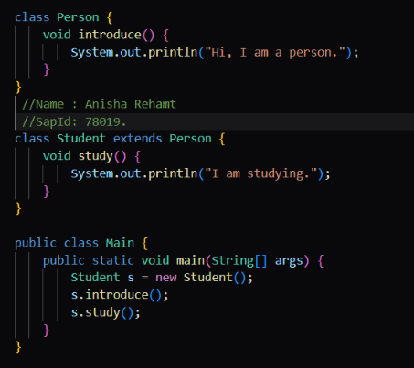
Output:-
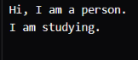
- We use single inheritance here as :
- A student has exactly one parent (Person) and gets introduce() from it. class Student extends Person is the inheritance line.

2. Build Grandfather → Father → Son, each with one method that prints its own name. Call all three on one Son object.

Code:-
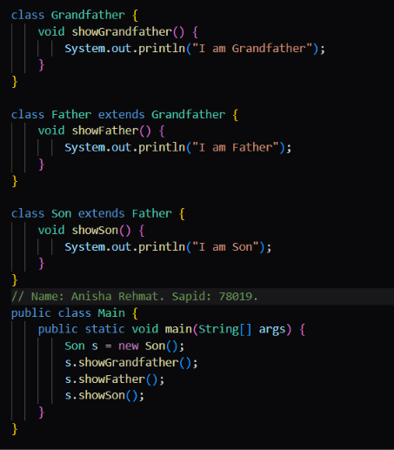
Output:-
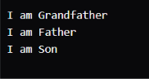

- We use multi level inheritance here as:
- The classes form a chain. Son extends Father, which extends Grandfather, so Son can call all three methods

3. make Employee (with showName()), then Manager and Engineer, each with its own showRole().

Code:-
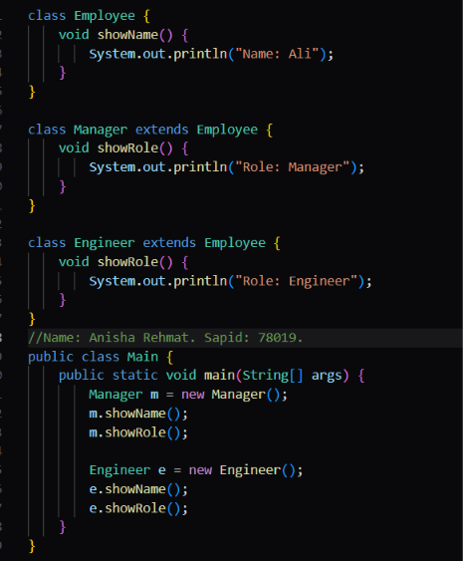
Output:-
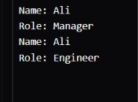
- We use hierarchical inheritance here.Two children (Manager, Engineer) share one parent (Employee). Both get showName(), and each adds its own showRole().

4. Make interfaces Printer (print()) and Scanner (scan()), then a class AllInOne that implements both.
Code:-
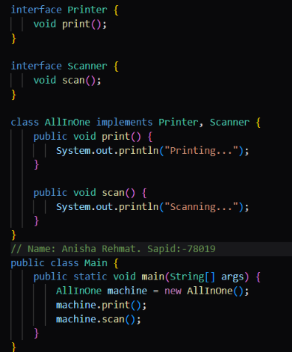
Output:-
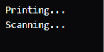
- One class has two parents. Java doesn’t allow extends for two classes, so AllInOne implements Printer, Scanner and writes both methods.

5. Create an interface Shape with void draw();. Make Circle and Square implement it with @Override. Store both in a Shape[] array and call draw() in a loop.
Code:-
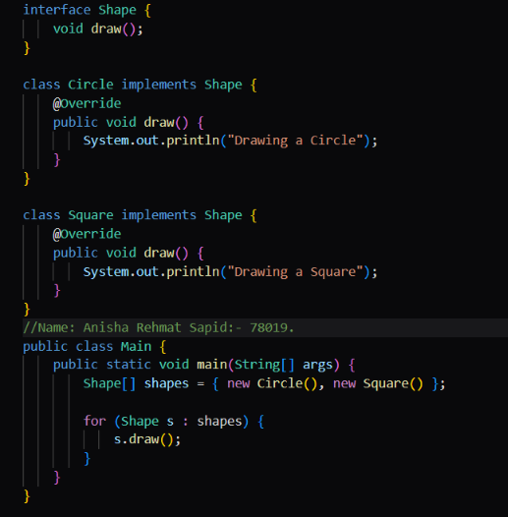
Output:-

- We use Interface and polymorphism here.Shape is a contract with nobody. Circle and Square sign it with implements and @Override. The Shape[] array calls draw() in a loop, and each object runs its own version.

6. Make an Employee with a constructor taking name. Make the manager call super(name) and also print a bonus line.
Code:-
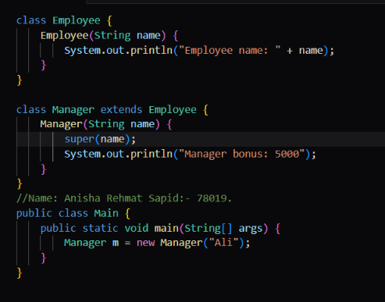
Output:-
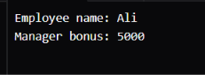

- We use single inheritance with super(....).The manager has one parent (Employee). super(name) is the first line of the Manager constructor and calls Employee’s constructor, so the parent sets itself up before the bonus line prints.

7. Predict the output (do not run it first):

class A { A() { System.out.print("A "); } }
class B extends A { B() { System.out.print("B "); } }
class C extends B { C() { System.out.print("C "); } }
public class Main {
public static void main(String[] args) { new C(); }
}
Answer:-
A B C
Code:-
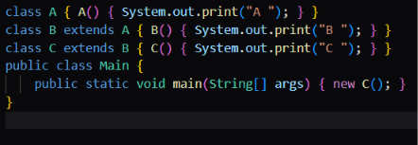
Output:-

Explanation:-
We use multilevel inheritance and constructor order.The chain is A → B → C. new C() runs A’s constructor first, then B’s, then C’s, so the output is A B C.

